**CRM OPPERATION SCHOOL AND COLLEGE**

**1.INTRODUCTION:**

**1.1 OVERVIEW:**

**Purpose The purpose of this paper is to explore customer relationship management (CRM) in a higher education setting. Design/methodology/approach The development and implementation of a CRM project in a state community college was examined as were the benefits realized by implementing CRM. As colleges increasingly embrace distance learning and e‐business, CRM will become stronger and more pervasive. Viewing students as customers provides a competitive advantage for higher education and enhances a college's ability to attract, retain and serve its customers**

**1.2 PURPOSE:**

**A CRM system can help educational organisations effectively manage and track leads, resulting in improved enrolment numbers. Additionally, by personalising communication and providing automated follow-up, educational organisation can build better relationships with students and leads, and keep them engaged over time**

**2.PROBLEM DEFINITION & DESIGN THINKING:**

**2.1 EMPATHY MAP:**

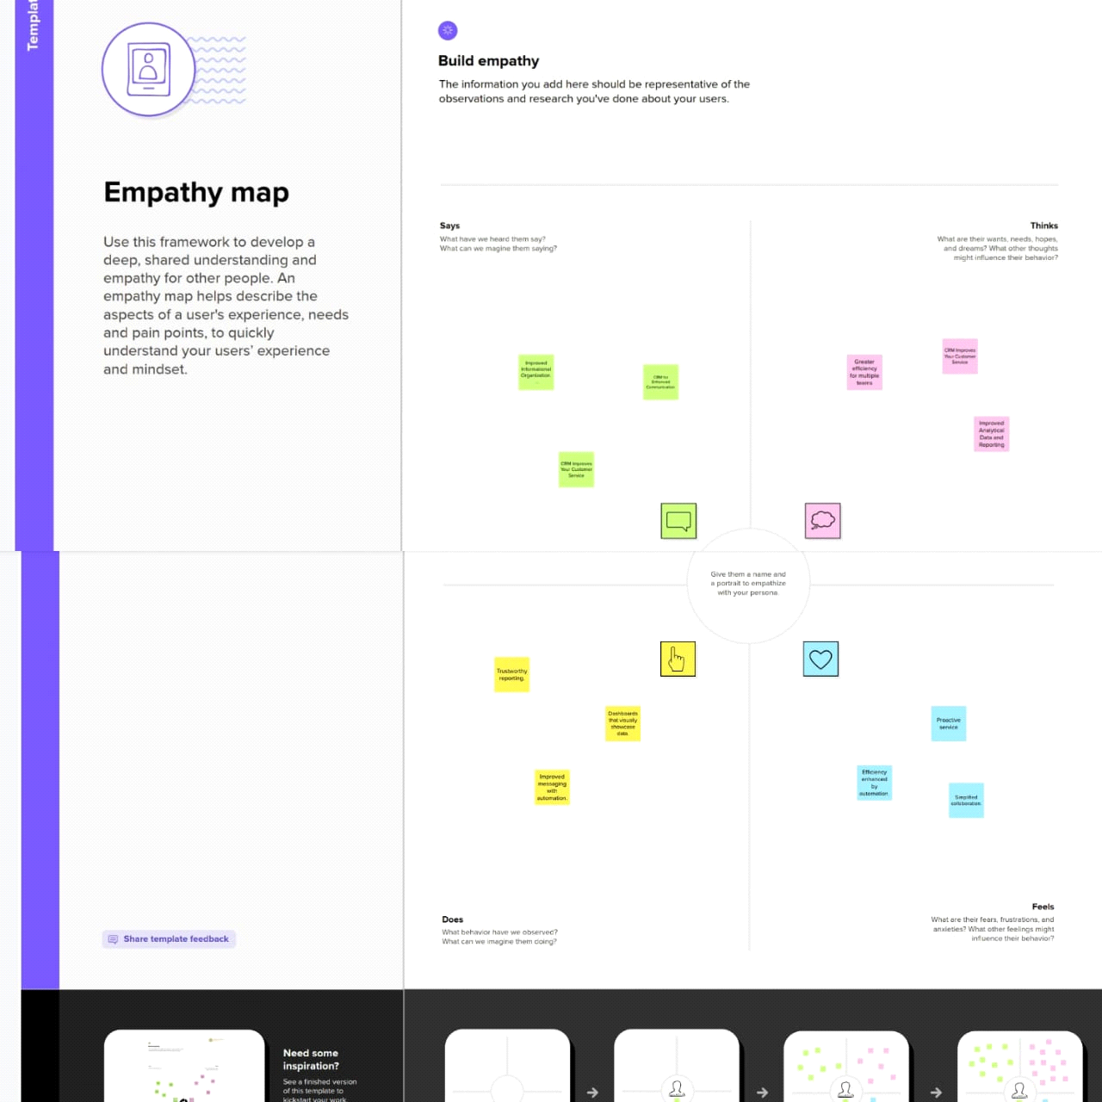

**2.2 IDEATION & BRAINSTORMING MAP:**

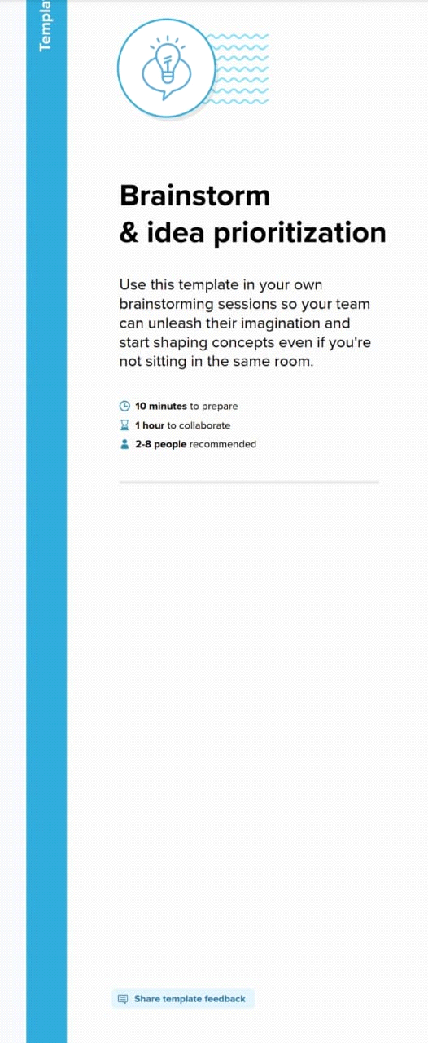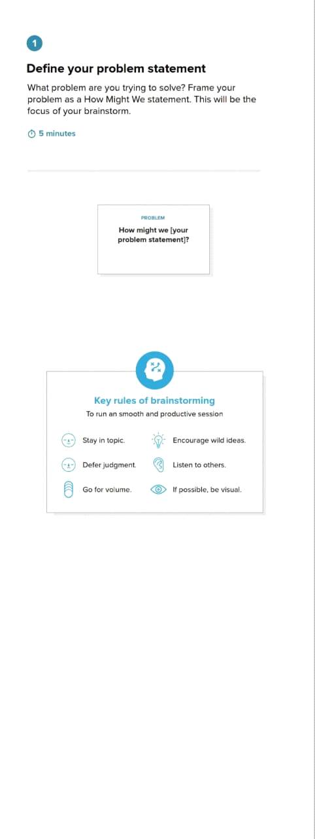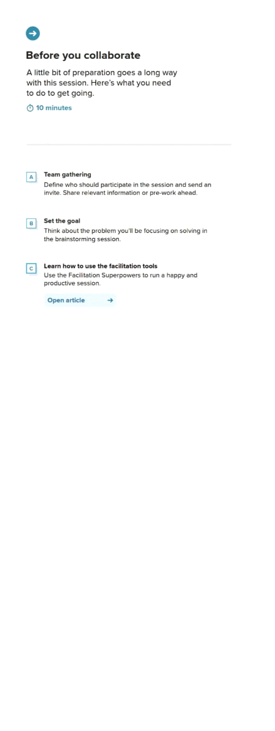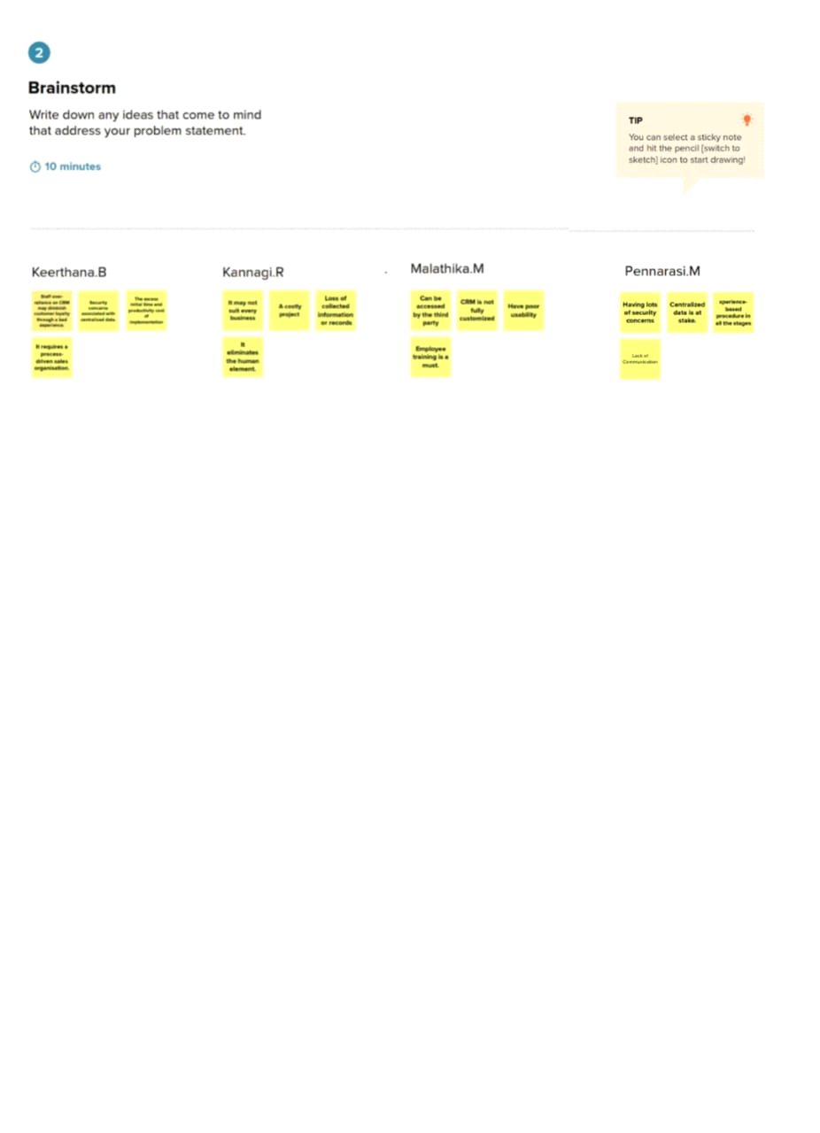

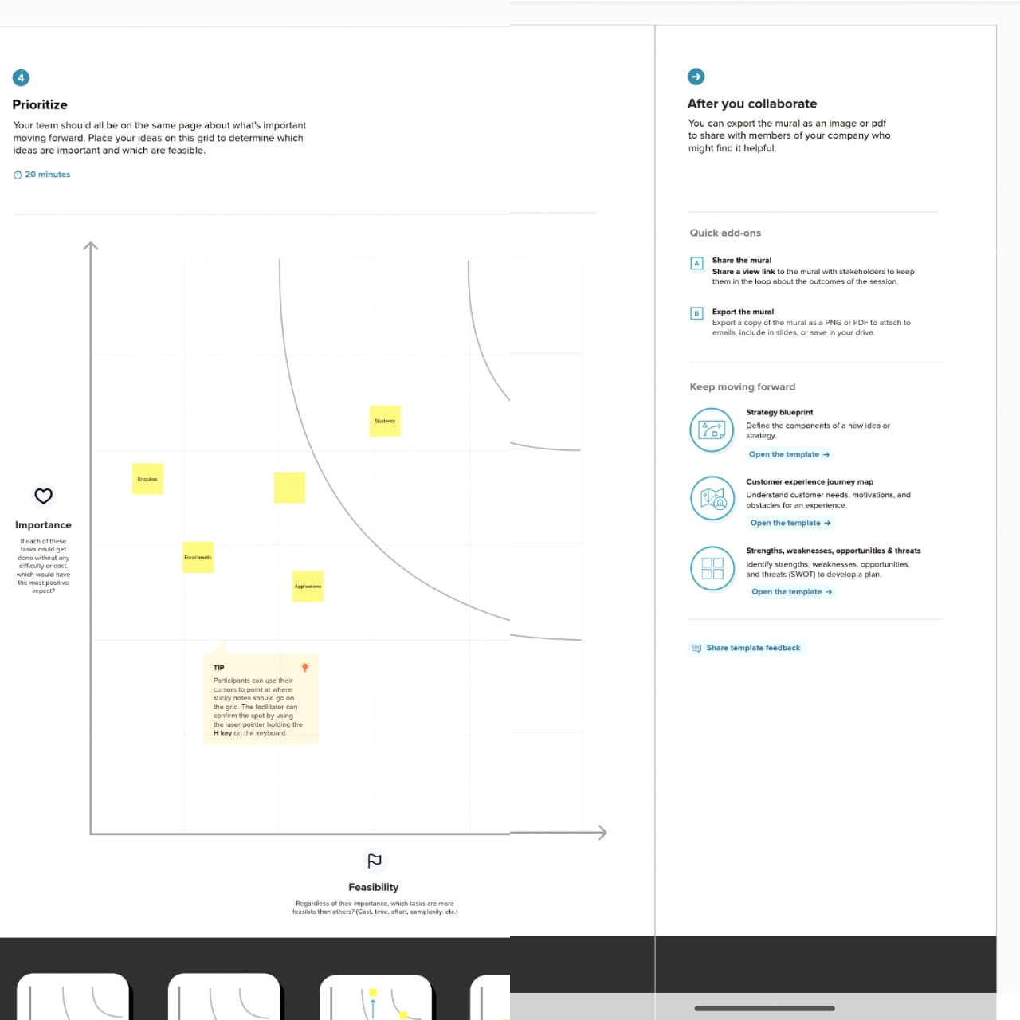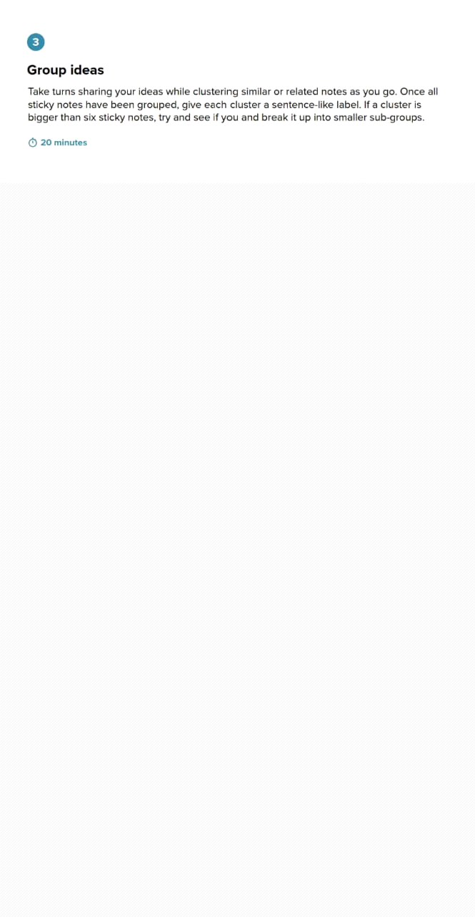

**3. RESULT:**

**3.1 DATA MODEL:**

**3.2 SCREENSHOT:**

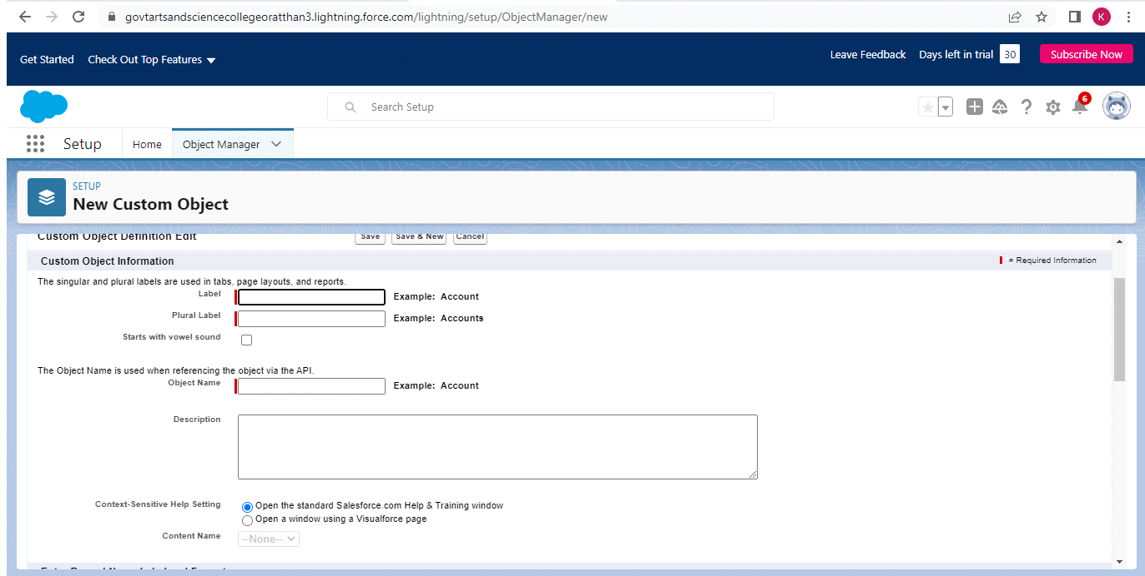

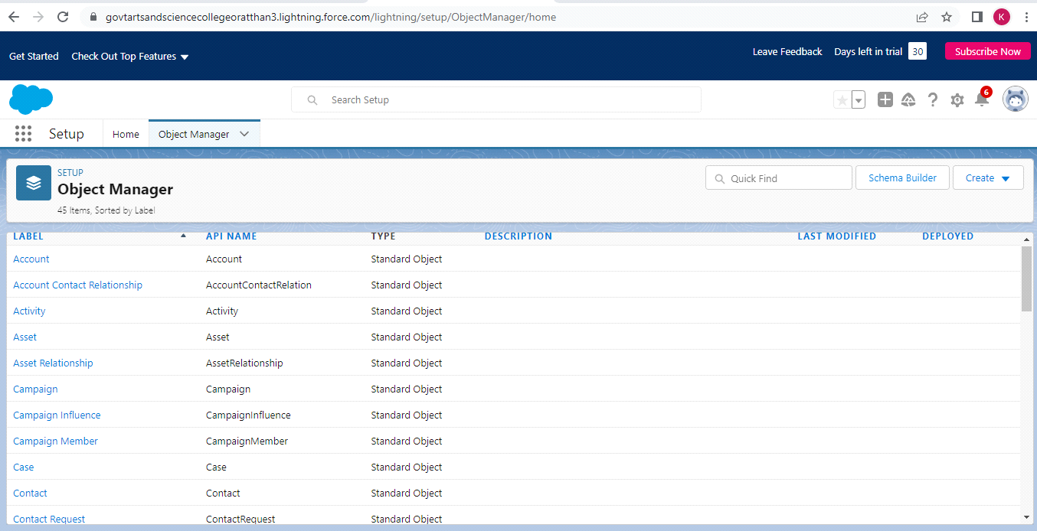

**4.TRAILHEAD PROFILE PUBLC URL:**

**Team lead -** [**https://trailblazer.me/id/keerb29**](https://trailblazer.me/id/keerb29)

**Team member 1 -**<https://trailblazer.me/id/kkannagimanjai>

**Team member 2 -**<https://trailblazer.me/id/mmathi108>

**Team member 3 -**<https://trailblazer.me/id/penna20>

**5.ADVANTAGES & DISADVANTAGE:**

**5.1 ADVANTAGES:**

**Improve Student Admissions Lifecycle**

**Track Student Life-Cycles Within the Institution**

**The student lifecycle begins with the admission and goes all the way to graduation.**

**Keep Alumni Information Safe and Accessible**

**Stay Connected with Teams**

**Monitor Fee Payments and Reminders**

**Track and Gain Insight on Organization-Wide Data and Processes**

**Reduce Operational Costs**

**5.2 DISADVANTAGE:**

**Loss of collected information or records**

**Not suitable for every business**

**It eliminates the human element**

**Can be accessed by the third party**

**CRM is not fully customized**

**Have poor usability**

**6.APPLICATION:**

**This means you will see trends and be informed faster as things grow and change. A CRM helps you know when it’s time to hire more people, alter internal processes, or invest resources into more production, before growing pains and panic sets in.Implementing an operational CRM platform means choosing to break through the ceiling of your sales potential.By accessing valuable insights that help you make better decisions, using customer insights to gain an upper hand on your competition, and developing processes that allow you to provide the same high quality of service even as your customer base grows, consider CRM solutions at the beginning of the next chapter for your business.**

**7.CONCLUSION:**

**A CRM centralises donor and alumni information and is used to send out automated communications at key times of the year to keep everyone updated on the success of the institution's programmes and students.**

**8.FUTURE SCOPE:**

**The future of CRM is about which companies will be able to pivot to meet the changing needs and trends — driven by customer expectations. Customers expect organizations to know a lot about them and expect to have conversations.**